**CSE-326**

**SYNOPSIS REPORT**

**PROJECT:** REVIEWS WEBSITE

**Section:** K19PG

**SUBMITTED BY: SUBMITTED TO:**

**Name:** Krati Garg Mr. Dipen Saini

**Roll No:** RK19PGB65

**Registration No:** 11913716

**Name**: Ankur Patel

**Roll No:** RK19PGB61

**Registration No:** 11905795

**Name:** Ansh Joshi

**Roll No:** RK19PGB50

**Registration No:** 11905461

**INTRODUCTION**

Our website “BONAFIDES” is a one stop website where you can get a deep insight into all kinds of enticing stuffs such as books, webseries, games and a lot more. No matter which gener you prefer or whether you are an old school or a millennial, you are at the right place to find the best time killers in concord with the flow of your heart and mind. In here, you will have access to the largest inventory of books with reviews which are cynical as well as praising. These reviews bring forth the true worth of the books and such is the case with webseries, movies, games as well. You would get to choose from a wide range of the above mentioned with filters that will bring to your eye only the things economical to you. You also find the most reliable and authentic sources and the links to the items you like. We regularly update the inventories with the intransigent trends and new releases.

**BLUEPRINT**

**HOME** (Bonafides)

Search

Home Gaming Books Movies & Webseries Shop SignUp More

**Gaming:** All the trending games, new releases, tips and tricks, link to download.

**Movies and webseries:** All movies and webseries reviews with their release dates.

**Books:** Reviews of all types of books with option of categorized searches, release dates, buy links.

**Sign Up:** Id/ password – Sign options.

**More:** About Us, Carrier in Bonafides, Contact Us.

**Graph**

**REFERENCES**

* [www.templated.com](http://www.templated.com)
* [www.websitesetup.com](http://www.websitesetup.com)
* [www.kinsta.com](http://www.kinsta.com)

***FINAL REPORT***

***HOME PAGE***

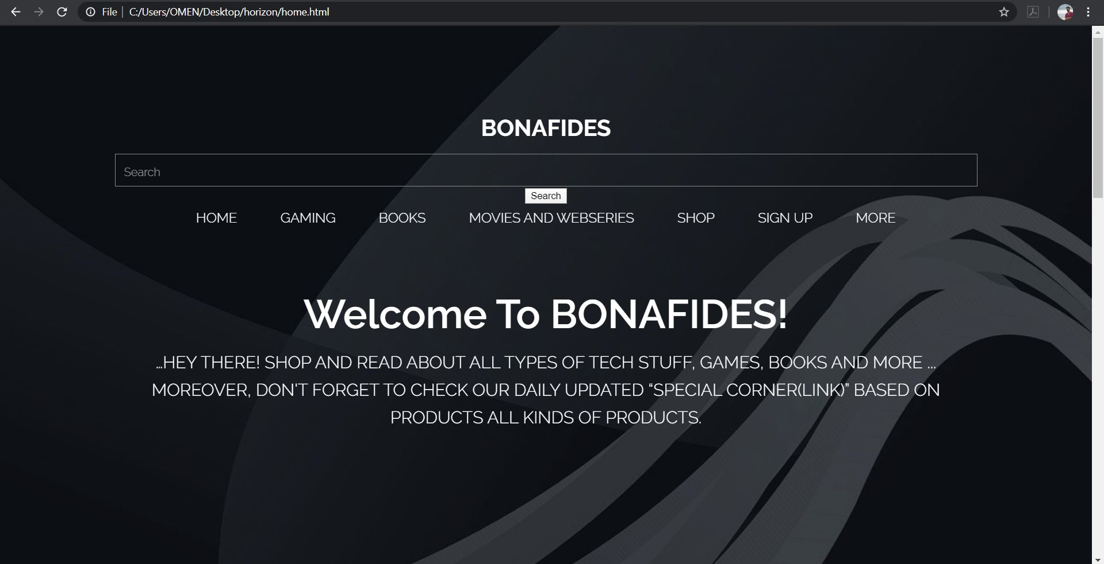

Our home page has the same navigation Tab with links all the other webpages.

You can browse to different pages like Gaming, Books, Movies, Web series etc.

Shop is being developed once the website is public than it can work.

When we come down we see a small introduction about the website.

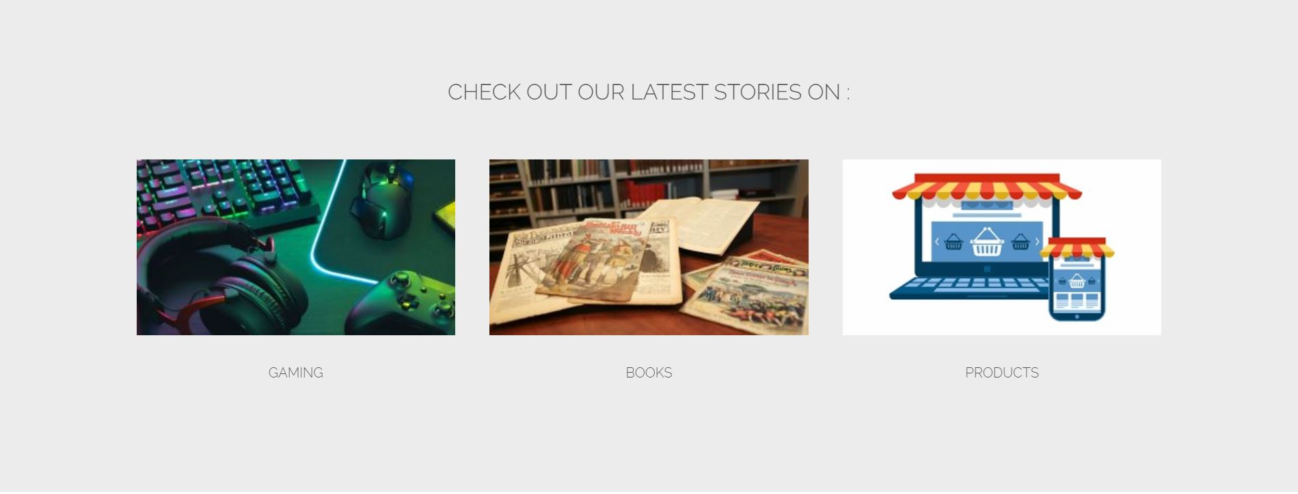

The middle of the website contains direct links to new stories related to certain categories which are mentioned above.

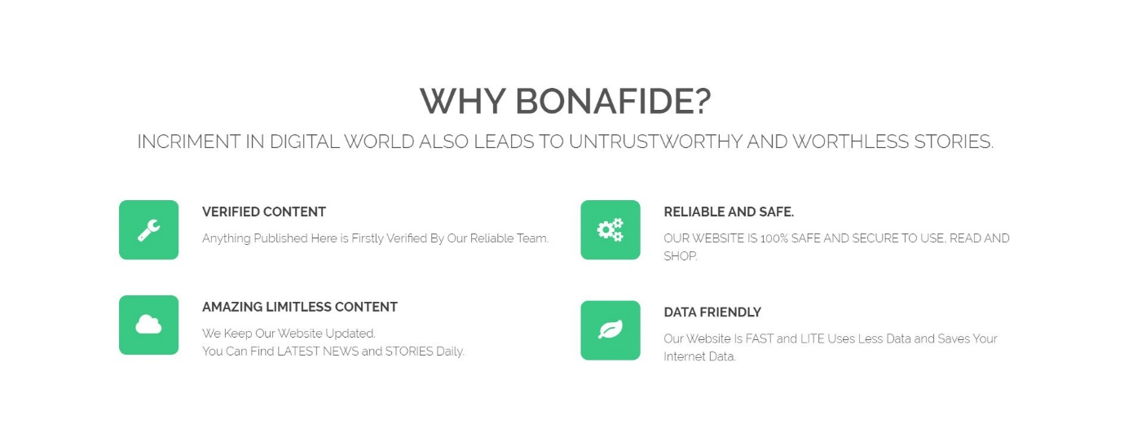

Lower Mid of the website describe about us i.e. why they should use our website and what is the highlight of our website.

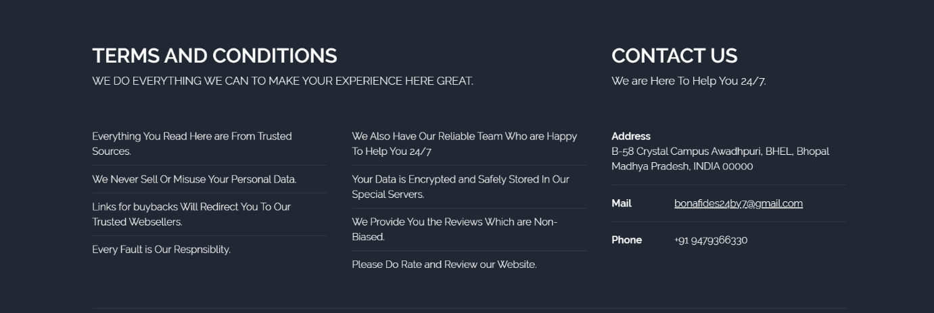

Last but not the least, last div tag contains our terms and conditions and contact us. Contact us contains the address of one of our makers.

Terms and conditions explains the rules and regulations of the BONAFIDES

***GAMING***

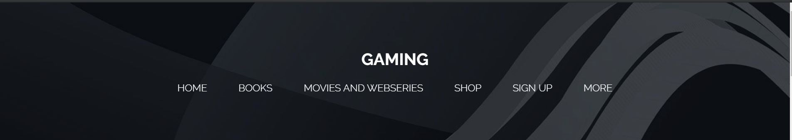

Like web-series, books column also has the same heading. It has the same background image we have used in every heading till date for this project.

Home leads us to the front page of the website, which is the opening page of the website. Second link leads to gaming page, third link refers to this books department only. Fourth link leads to our shop, under which we will be providing affiliate links to various products as per the circumstances. But all the companies providing affiliate links ask for how much traffic our website can gather, so this apartment will be functional only after our website starts to gather some audience

Under more there are further some links of web-series and many things, but of course, as we have used mouse roll over JavaScript, so we can’t really display the contents.

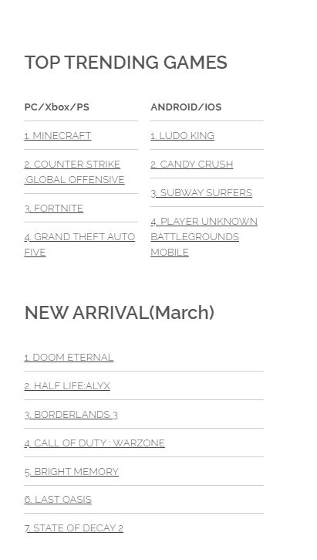

In the Right side of the Gaming Tab You will see all the list of tending games on all the platforms trending during last 7 days.

Just below that we have top 7 new arrived games in that particular month i.e. in march above games are hit new releases.

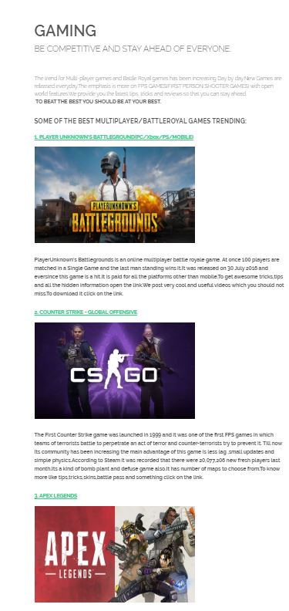

In the Left side below the navigation tab we have all the battle royal games which are in fashion.

These are the games with description if click on their name or the picture it redirects you to the special information about the game, tricks, tips and certain videos which can help you improve.

In this redirected page it also contains procedure to download or buy this game.



Last but not the least, last div tag contains our terms and conditions and contact us. Contact us contains the address of one of our makers.

Terms and conditions explains the rules and regulations of the BONAFIDES

***BOOKS***



Like web-series, books column also has the same heading. It has the same background image we have used in every heading till date for this project.

Home leads us to the front page of the website, which is the opening page of the website. Second link leads to gaming page, third link refers to this books department only. Fourth link leads to our shop, under which we will be providing affiliate links to various products as per the circumstances. But all the companies providing affiliate links ask for how much traffic our website can gather, so this apartment will be functional only after our website starts to gather some audience

Under more there are further some links of web-series and many things, but of course, as we have used mouse roll over JavaScript, so we can’t really display the contents.

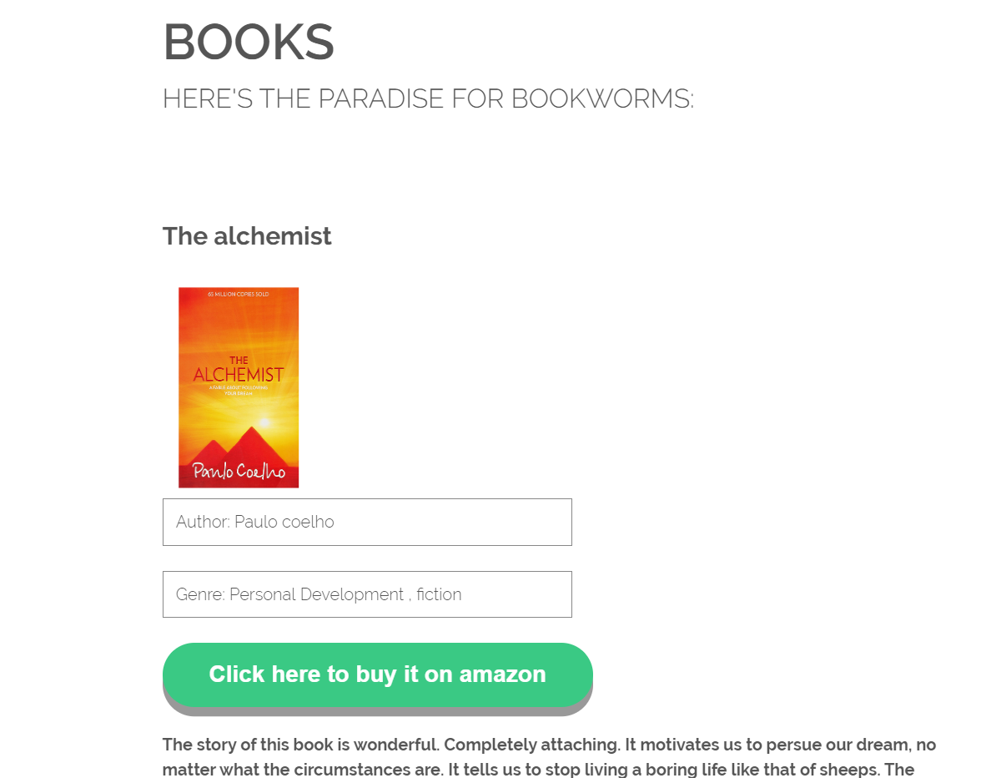

Here we start writing the reviews of the books. We have first kept the photo of the book we want to start writing about. Then, we told about the author and genre of the book. Down we have mentioned an affiliate link which would start working once we become affiliates. And below that we have started to write the review of the book. We acknowledge the user a bit about the story and then review the book.

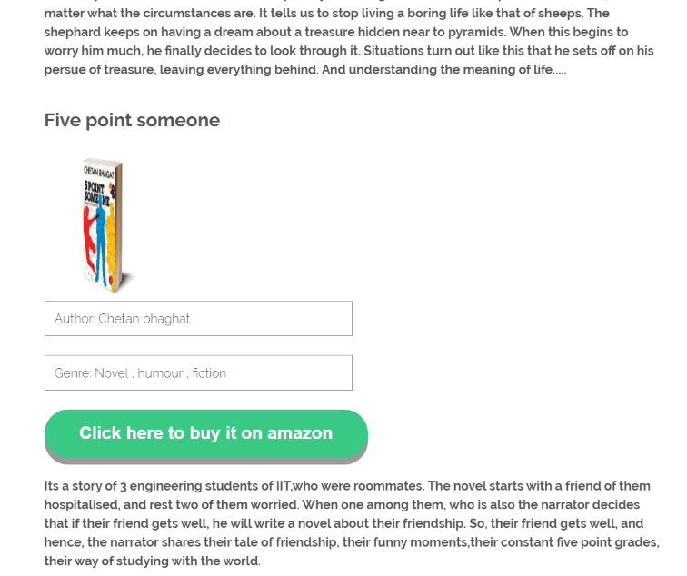

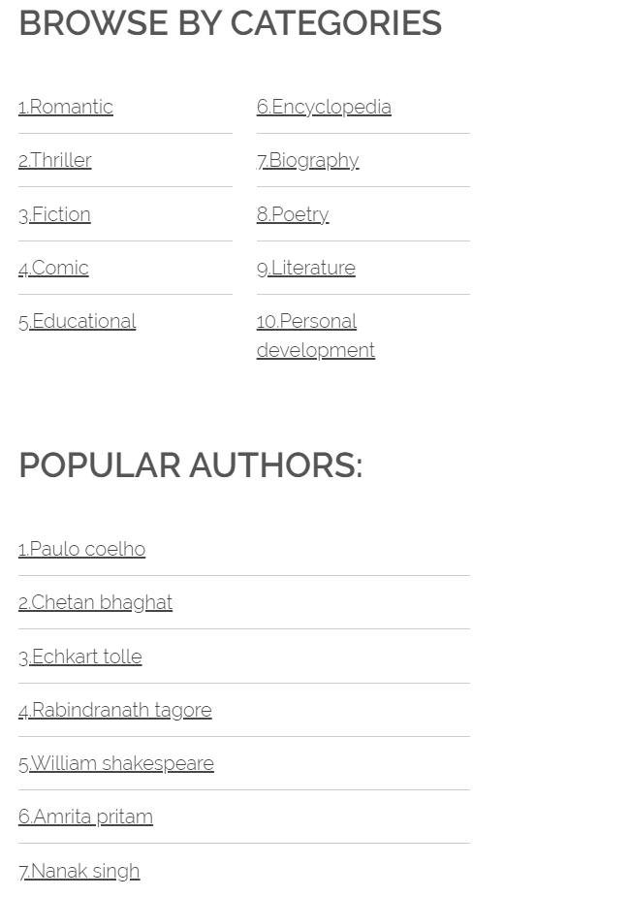

Here is our browsing section, where users can search the books by their genre, or categories.

Also, user can search the books department using the author he/she wants to read about. We refer here the famous authors, which we will be adding further on.

Of course the list of books reviewed is long, and we can’t post snip of every review.



Last but not the least, last div tag contains our terms and conditions and contact us. Contact us contains the address of one of our makers.

Terms and conditions explains the rules and regulations of the BONAFIDES

***MOVIES AND WEB-SERIES***



In the movies and web-series section top part is the heading, which is of course movies and web-series. We have made navigation tab above, one link leading to home, or our first page. Second link is gaming, which leads to gaming reviews page, third link is books, leading to page of reviews of books. Our fourth link is of shop, which will be added lately. Once our website starts working and starts to gain traffic, we will affiliate products from other shopping sites related to books, games and many more.

Last but not the least is more, having mouse rollover JavaScript, hence we can’t take the snip of it. It further contains many links, one among which is movies and web-series i.e., our current page.

In the background we have used an image, which is already given in the folder given alongside with the project

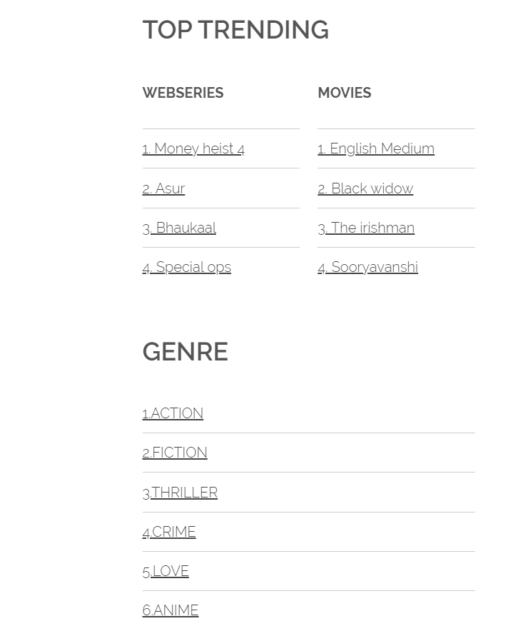

Here in this div tag, we have put many links to different trending web-series and movies as per the given time. Also, we have categorised different web-series according to the genres, such as action, fiction, thriller, love, anime etc etc ……

Each of the word acts as a link to different pages, and hence lead to the reviews of trending movies

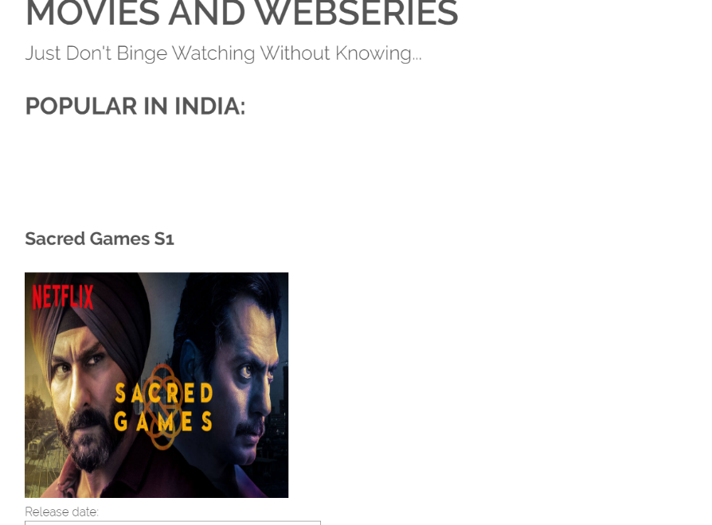

Now we start writing about the reviews of different web-series and movies. Like shown in the photo, we had started with the crime thriller Indian cinema, sacred games, and it continues on and on.

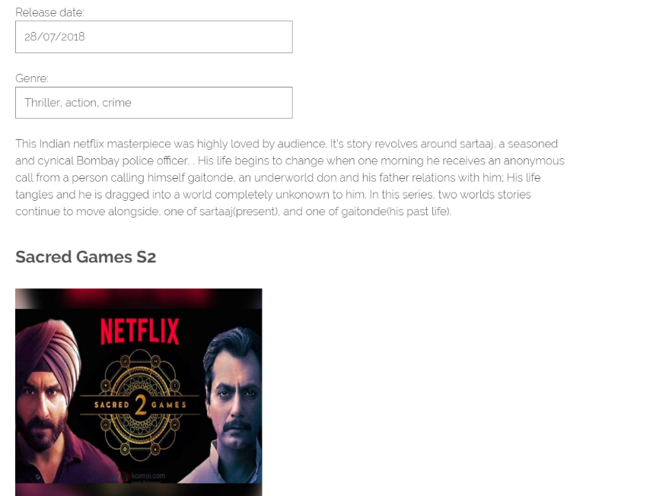

We tell the user about the genre of the movie and release date of the web-series, and movies. And list goes on.

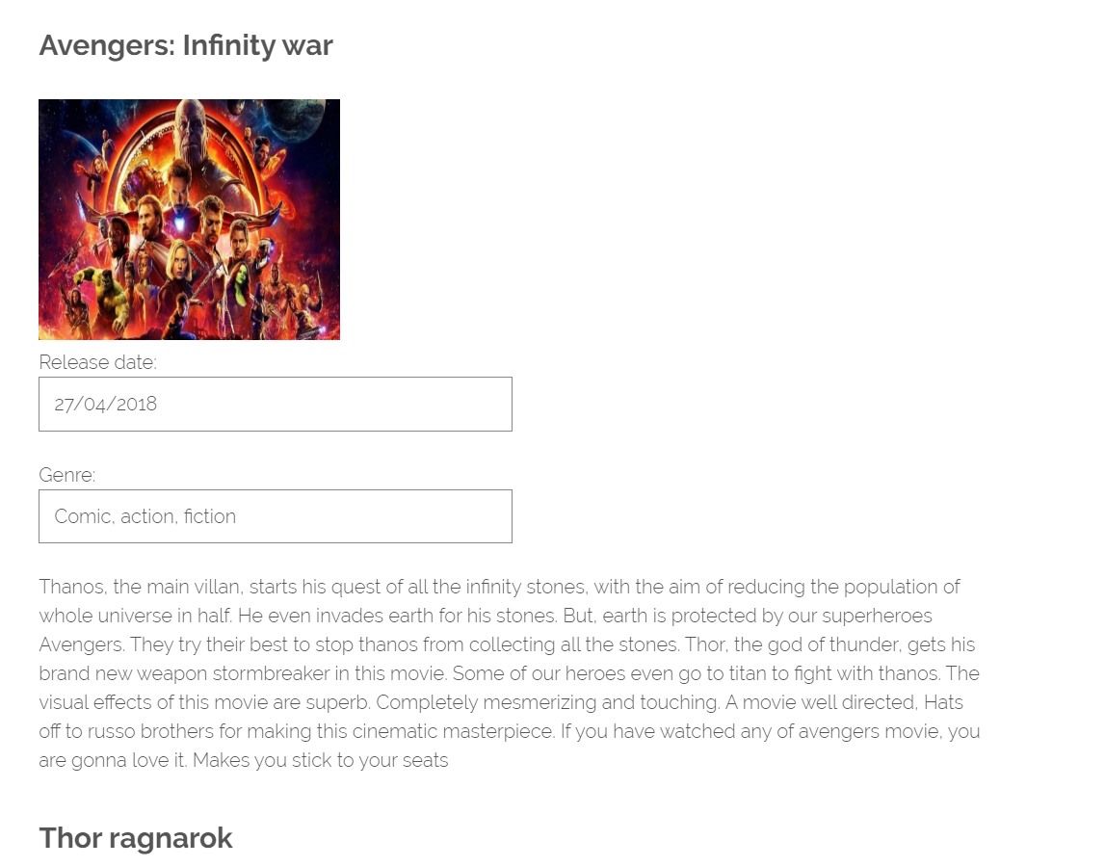

We have given information of many movies also, be it Indian or Hollywood, or be it Crime thriller or comic book-based movies

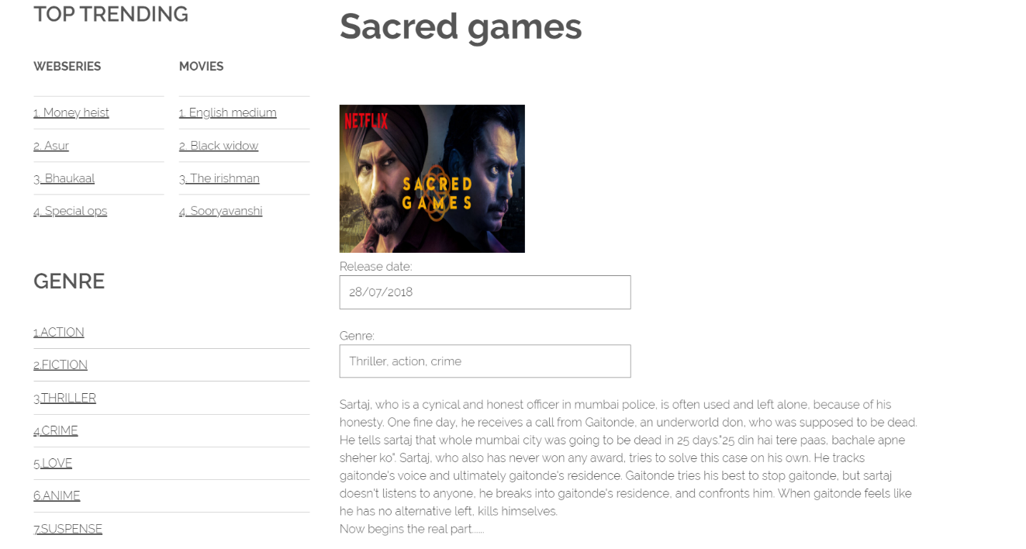

We have also used the image and the title as the tag, which opens up to another page with in detail description of the story of movie or story.

It however does not disclose the plot or climax of the movie, it ends near to the climax of the movie keeping the secrecy of the movie, also keeping the user interested in the movie.

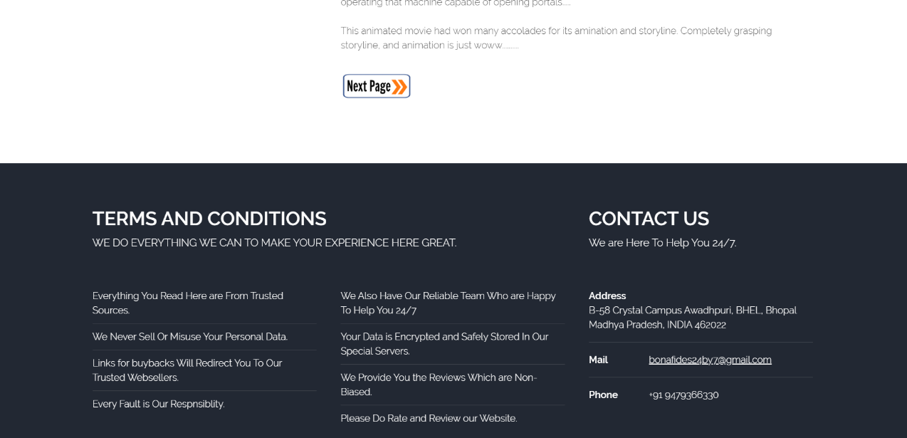

In the bottom most tag, like the previous one home page, contains the terms and conditions, and address, if anyone wants to contact us.

Also, our movies and web-series content, as thought, is large. So we have added some of this content in another page also.

***SIGN UP***

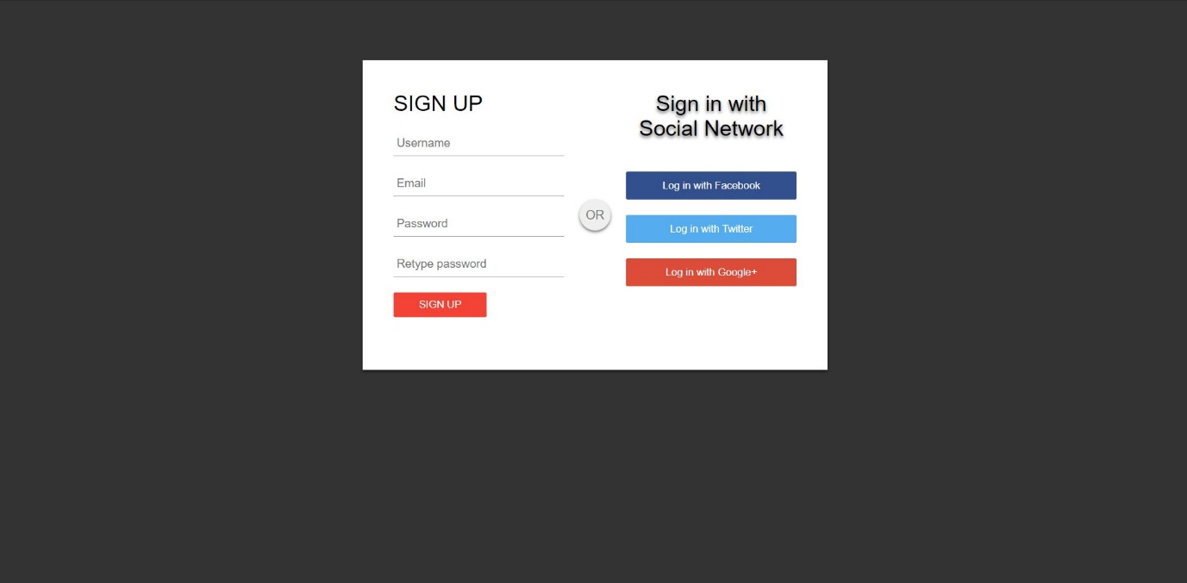

SIGN UP tab is used to take user information so that we can provide them regular updates and also can link them with us for future use.

Also if in future we want to add something in which we can benefit our old users so this is the only way to identify them.